Discover-hollywood User Guide

You can sign up here.

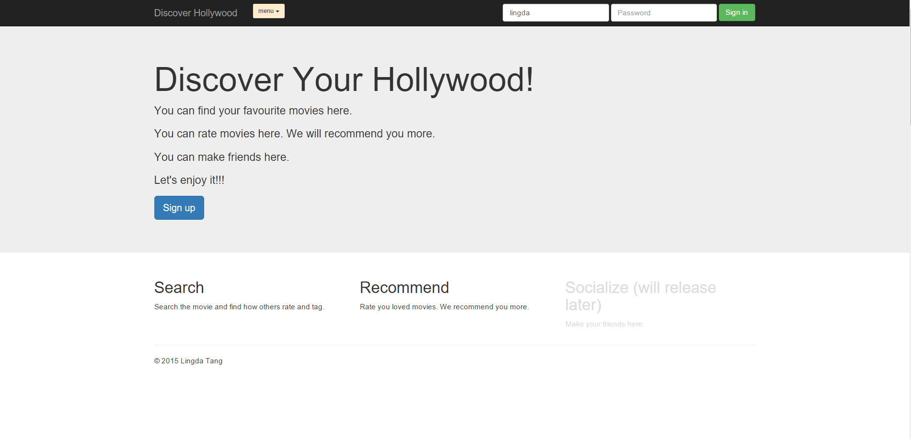

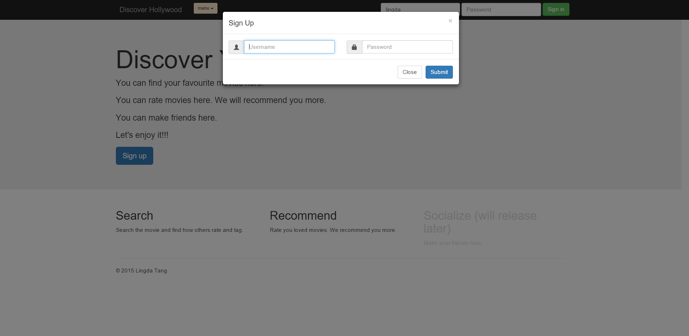

Once you have signed up, the system will ask you to choose three genres that you like.

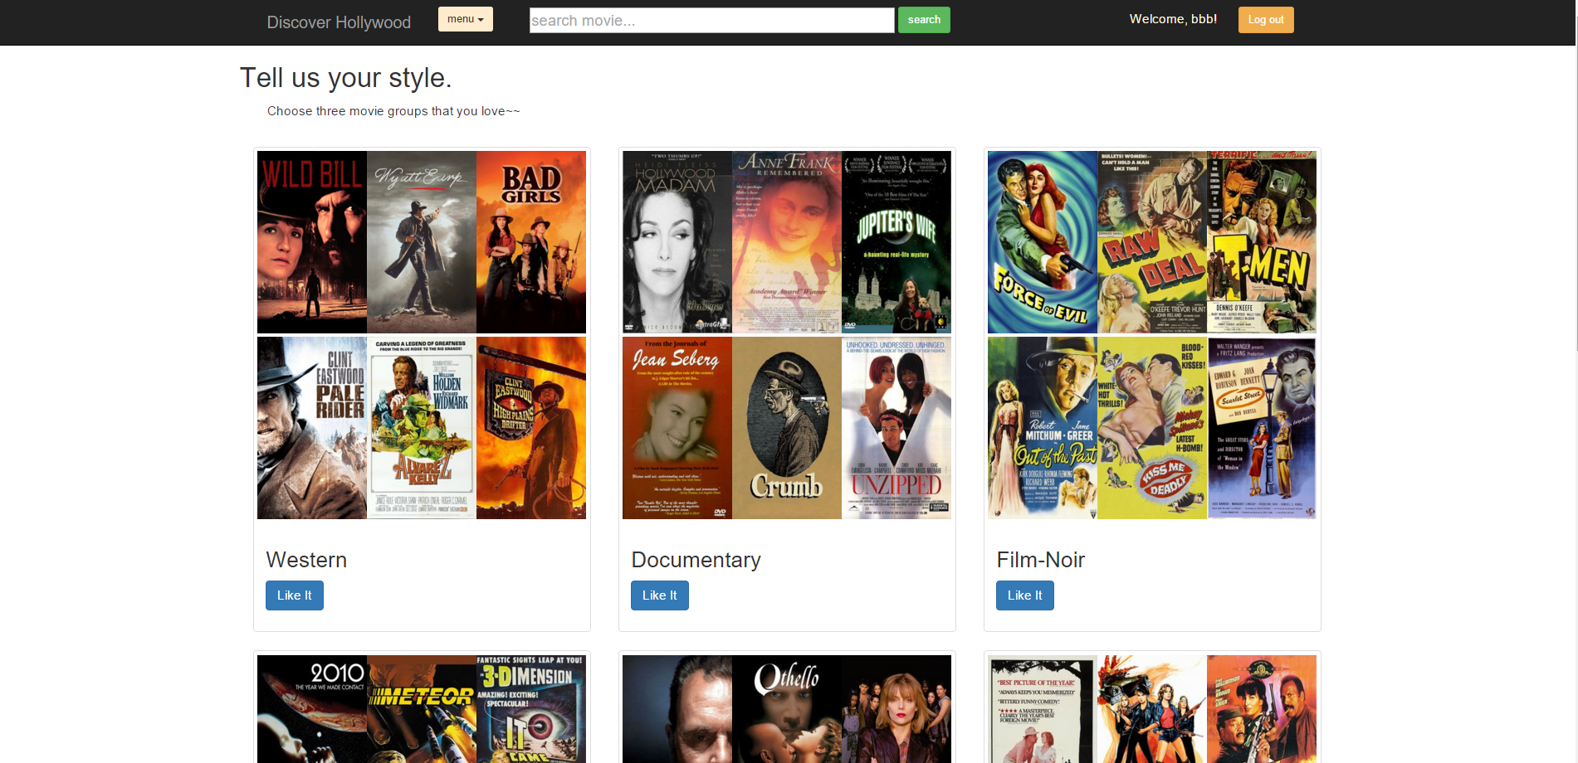

After that, the ‘go to the movie hall’ button will show and lead to the movie hall.

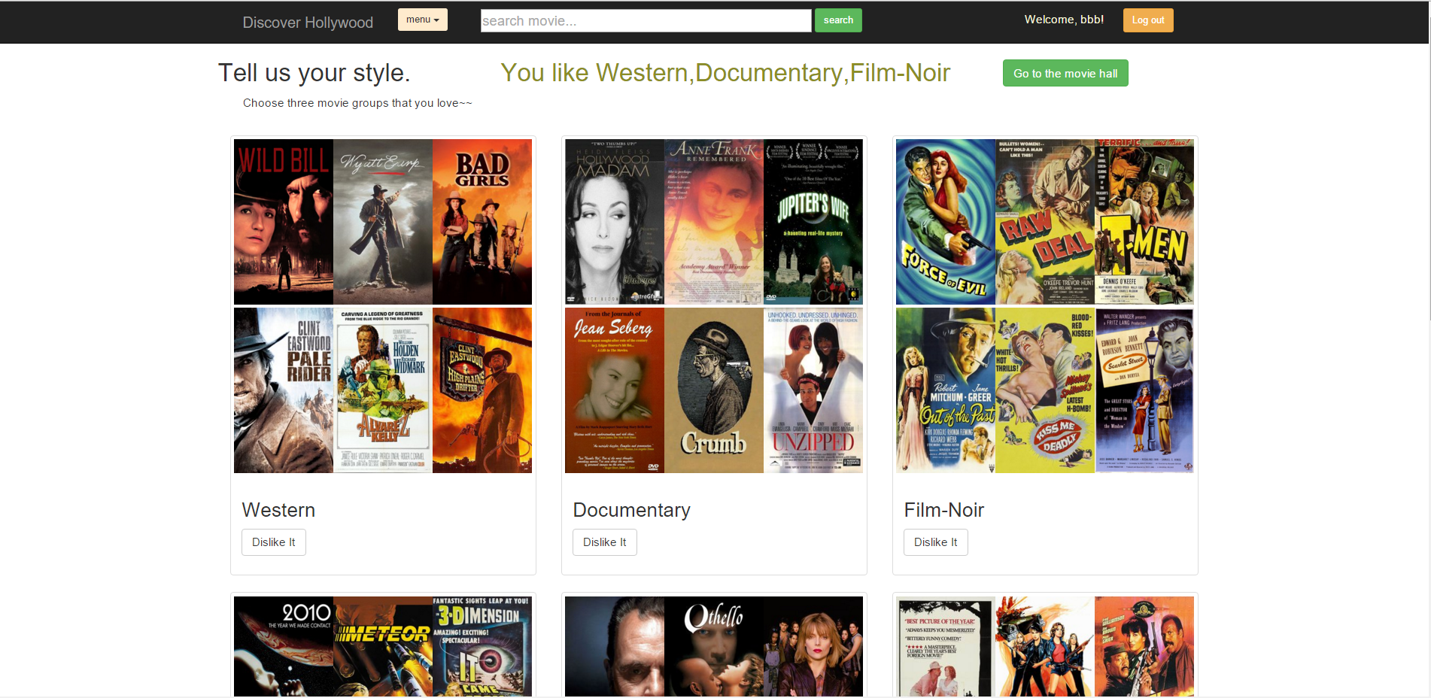

After you have entered the movie hall. the system will recommend you some movies based on your genres appetite and your rating history. Also the highest rated movies and the most rated movies will show too.

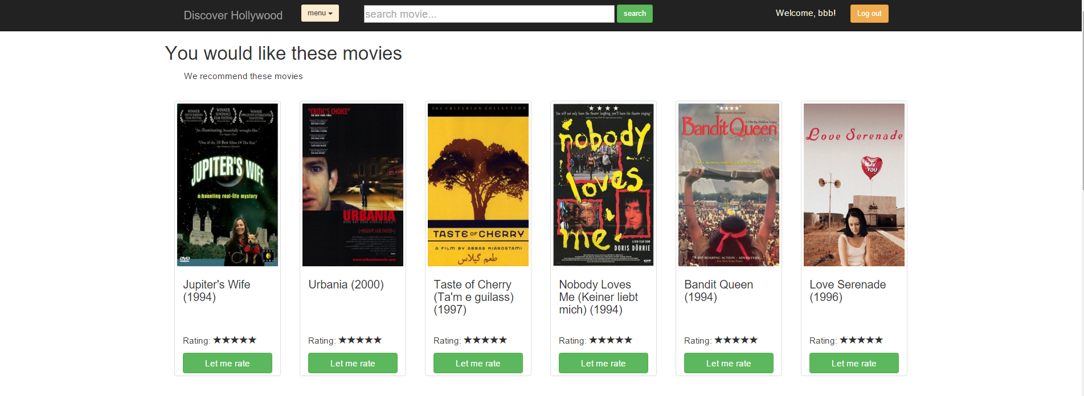

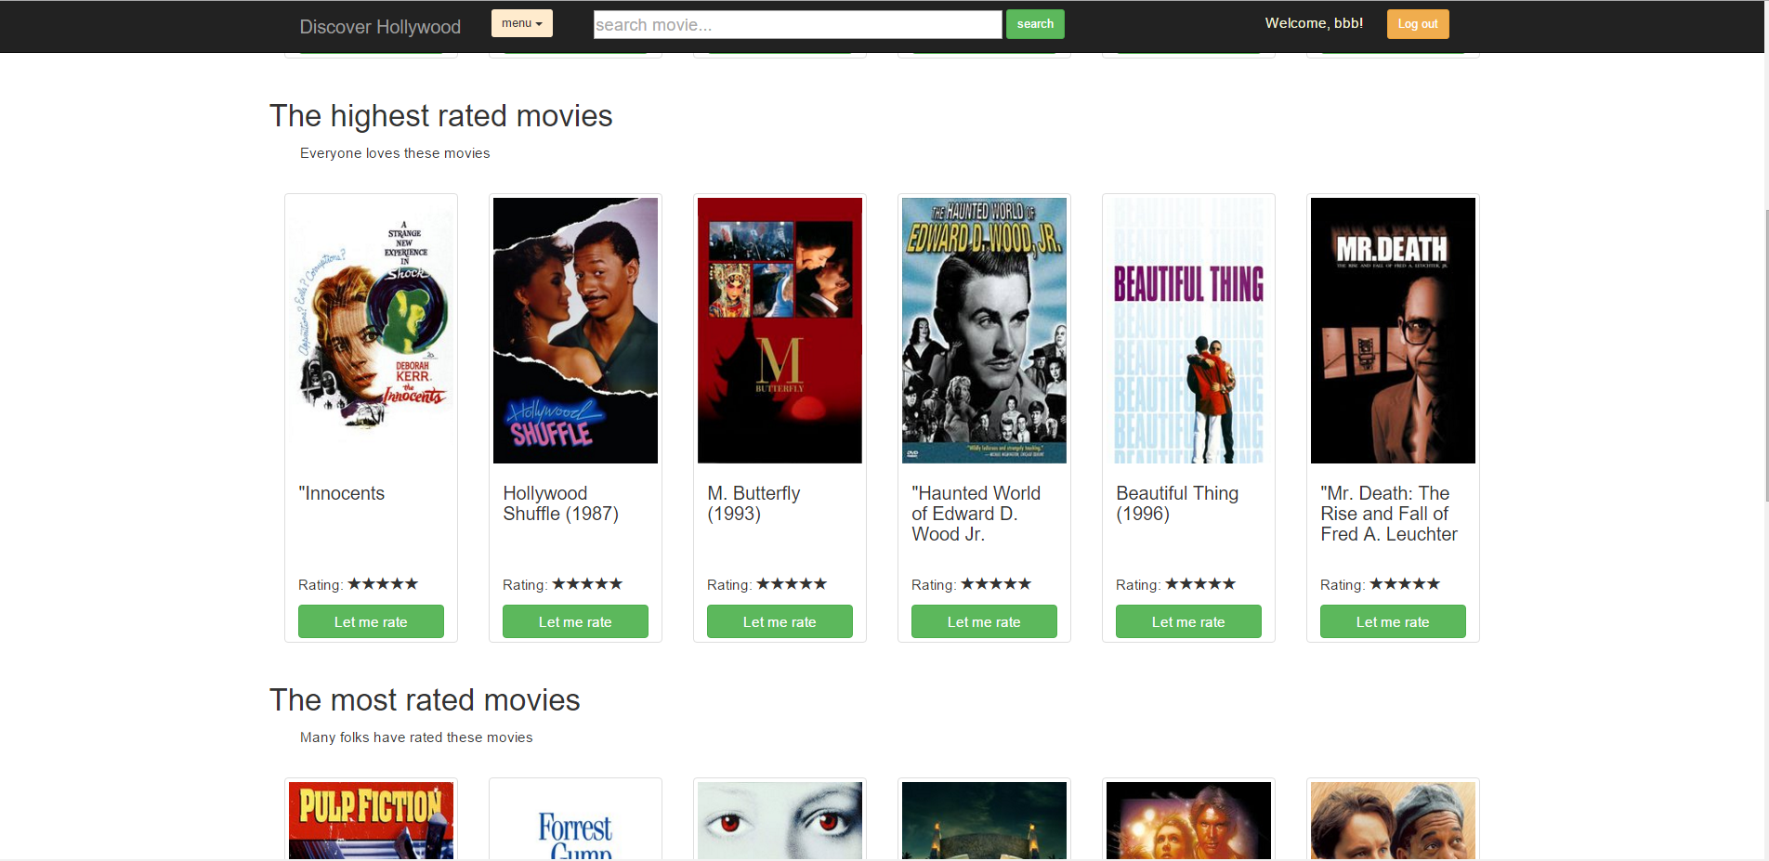

You can click the ‘let me rate’button to give your rating to this movie.

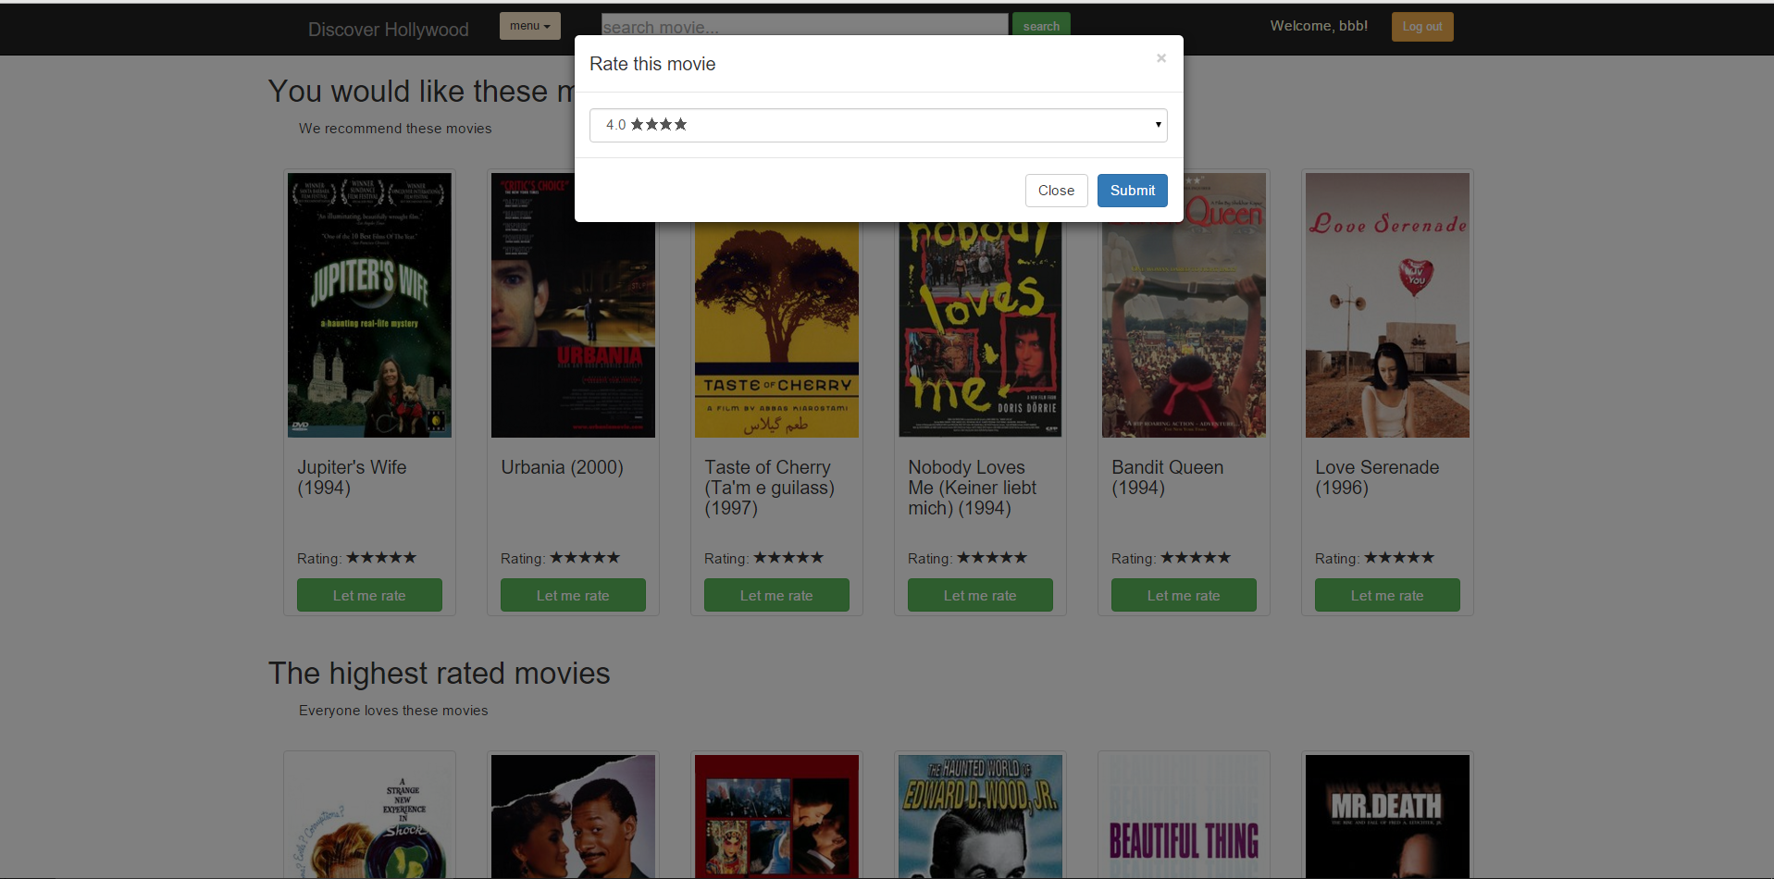

Also you can type something to search what you want.

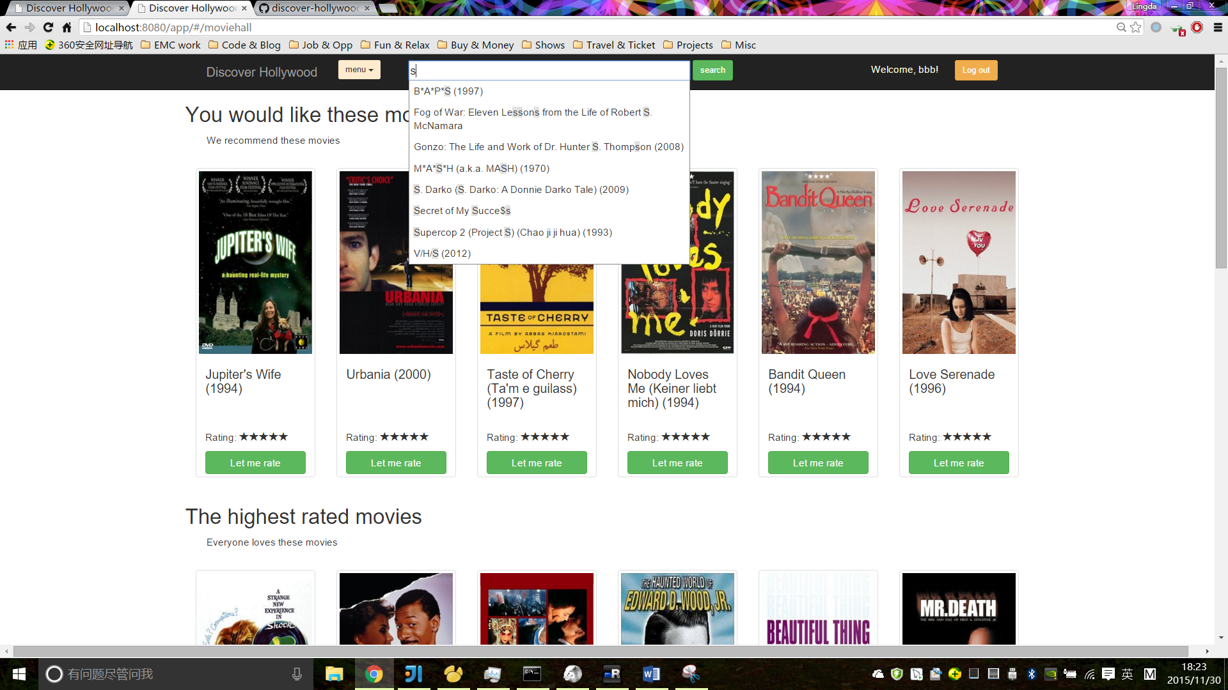

You can see result after you search something. And you can see how others tag and rate this movie. You can see the poster and the description of the movie. The ‘let me rate’ and ‘let me tag’ buttons enable you to rate and tag the movie.

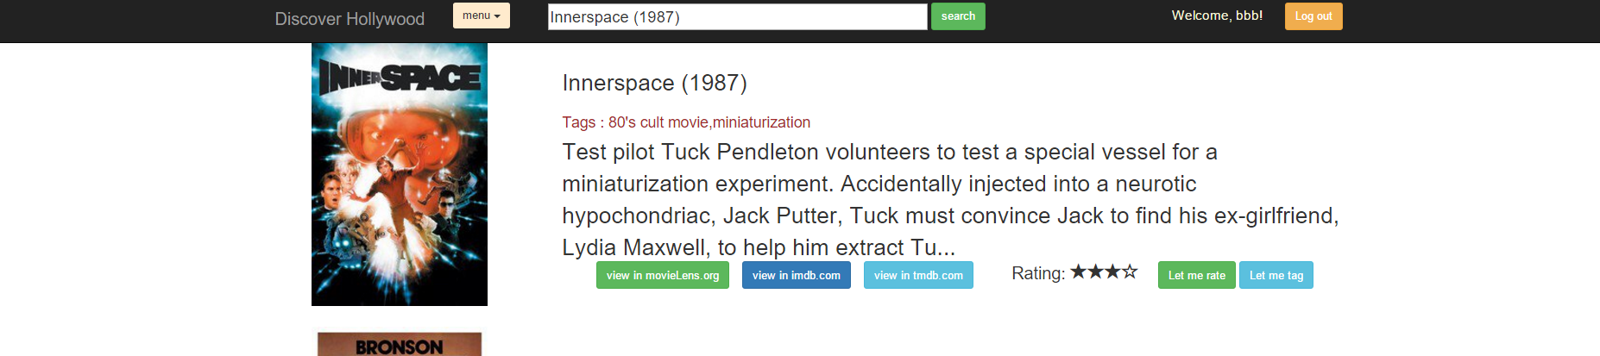

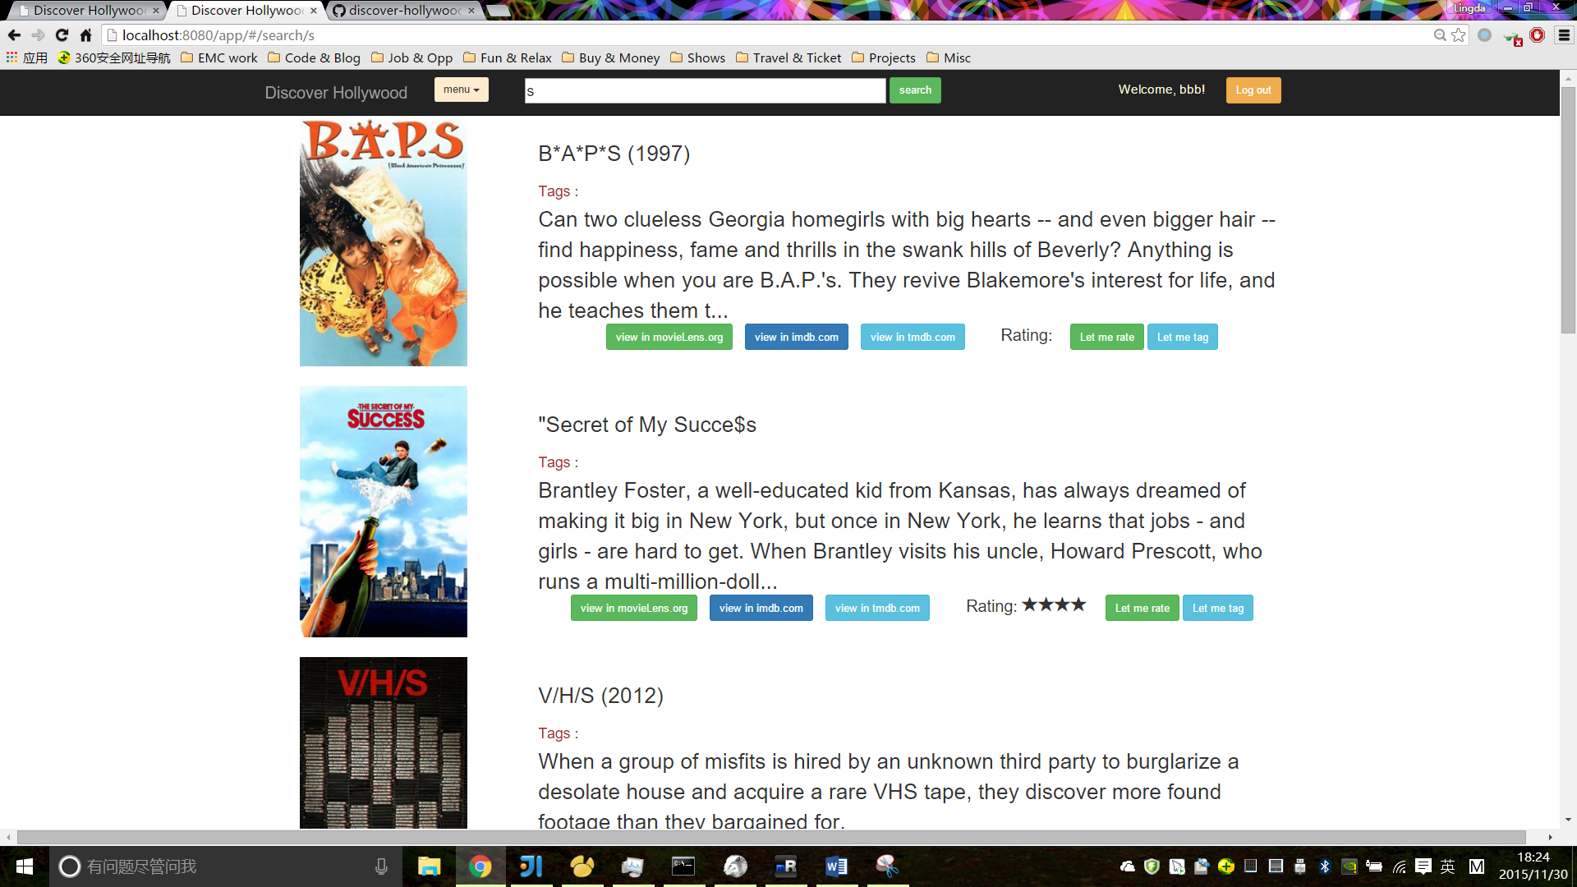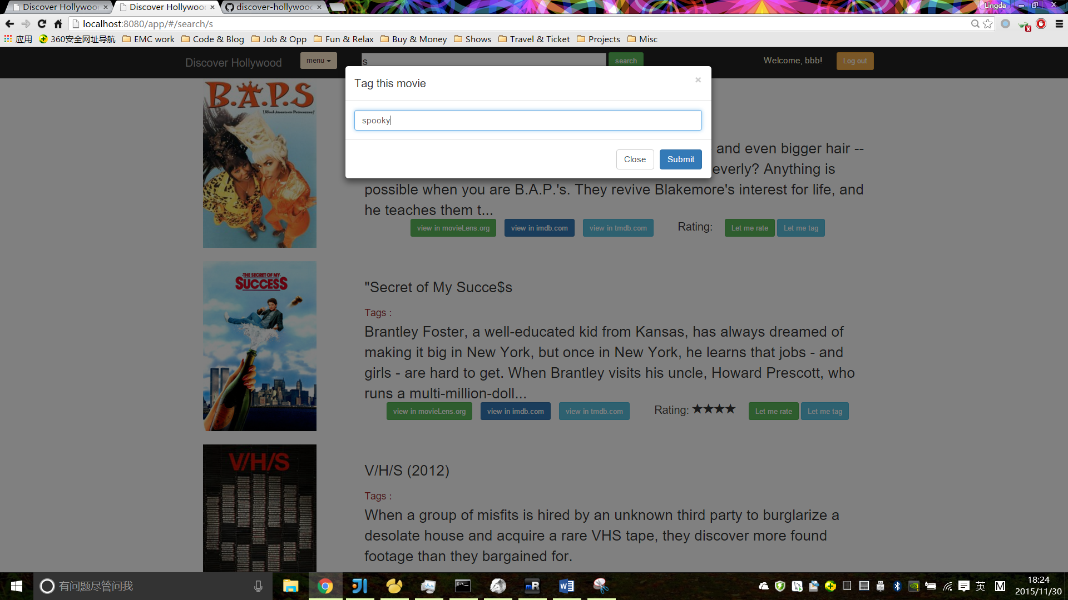

You can see your rated movies.

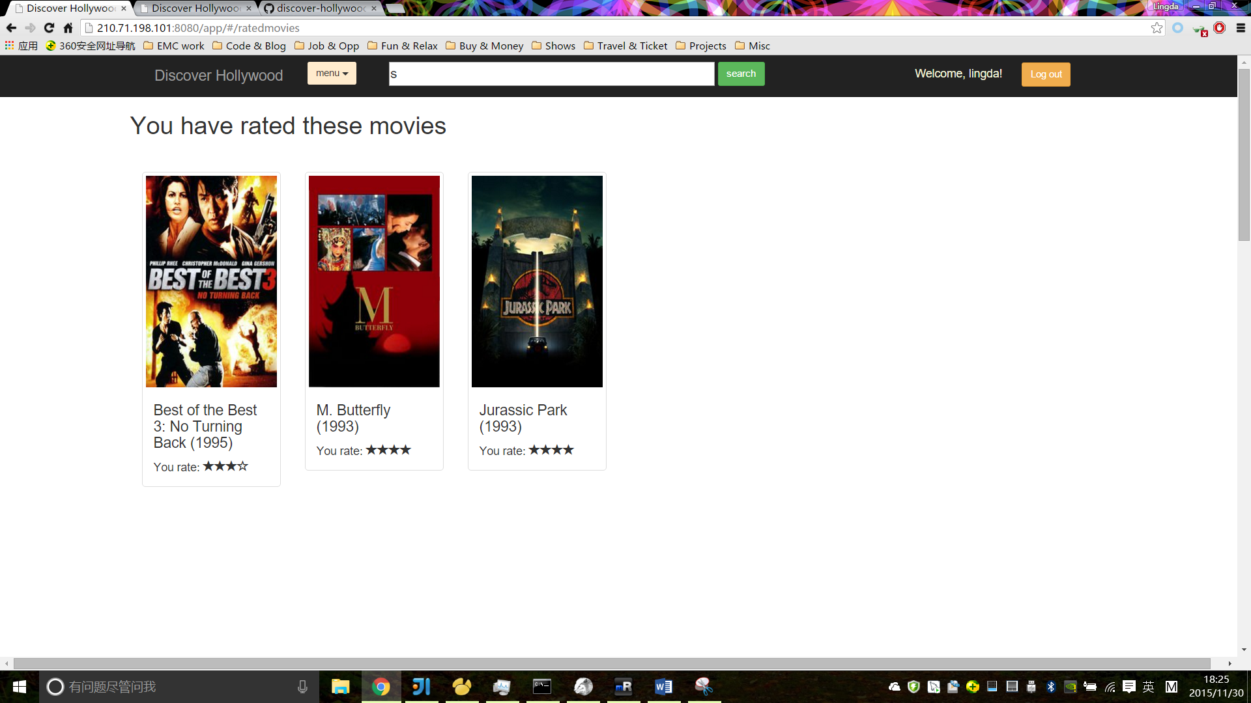

Also you can see your tagged movies.

